DIY DAW Controller with Teensy: Hardware Creation on a Budget

Authors: Music Junkies of CMPS 375

Christopher Wunstel, Rory Avant, Tony Hoss, Christopher Vasquez

Advisor: Dr. Kuo Pao Yang

Computer Science and Industrial Technology Department

Southeastern Louisiana University

Hammond, LA 70402 USA

***Abstract-***

***When using a DAW to create and perform music, professional DJ’s and artists use a variety of controllers, keyboards, and mixers to operate the software. The other choice available to musicians is to use the keyboard and mouse for interacting with the software. This way of working with the DAW loses the ‘old-school’ feeling of mixing; the actual disc jockey work of producing music. As musicians just starting out, as well as students, money is not a luxury available to help buy one of these expensive machines. Using affordable microcontrollers and parts from the Teensy and Arduino line, a controller was successfully created. The approach, steps, and comparisons of other methods will be discussed.***

***Keywords-***

***Teensy; Arduino; Hardware; DAW (Digital Audio Workstation)***

I. INTRODUCTION

As a group of musicians that work with music software, primarily the Digital Audio Workstation (DAW), in its many flavors, creative results are what we crave for. From high quality production to original mixes, the heart of music production (or music making in any way) is to achieve a result with good sound. After all, music is merely entertainment; but it is so much more than that at the same time. Not everyone has the time to learn and master an instrument, as that takes years of commitment. Even so, much music today is produced by electronic means, evolving from a purely acoustical means to an end. Much music is produced electronically, not just for convenience, but for the sounds that can be produced only with a computer.

That is where the DAW comes in; many people can learn to use and incorporate a DAW of their choice into their work. Whether using Ableton Live, Studio One, or FL Studio, a DAW is the computer musician’s instrument. It allows artists to compose music that is personally satisfying to music that is used to head festivals worldwide. It is where all the effort and hard work of composing, producing, and/or performing is stored for the world to see. These types of software programs by themselves are expensive. When using them, people are limited using the mouse and keyboard.

With acoustical instruments, musicians can practice on the instruments themselves; in older days, when people created music by electronic means, their primary devices were synthesizers, sequencers, and magnetic tape. When it came to performance, the old disc jockey way of scratching vinyls was the means of expressing their artistic souls to people.

There is a positive and negative to the DAW to put it simply; there is so much that can be done with the DAW that it can make the experience of creating music seem too robotic, taking the organic, human part of it out of the process. This is especially noted when using the DAW with only a keyboard and mouse; the tactile feel of making electronic music is absent due to no synthesizers, the instruments for an electronic musician.

This paper focuses on making a cheap controller for using the DAW to give an old school feeling of making music that is within a $30 budget.

II. RELATED WORK

There are many people who have started to realize the potential of Arduino, especially artists. Until recently, musicians have relied on instrument and software manufacturers for the tools needed to create and manipulate sound[1]. With the Arduino, which is still relatively new, these artists can now create and implement their own instruments and instrument controllers[2]. This results in much lower spending for the computer musician, as brand name products usually have a high price tag attached to them, from Yamaha to Korg to Native Instruments.

While these controllers are well made, and perform the job perfectly (why they are used by the world’s highest paid DJ’s and other electronica artists), they do lack a certain thing that is available with using open source hardware microcontrollers: individuality.

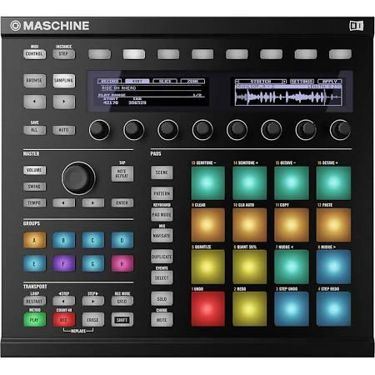

Figure 1. Native Instruments Maschine MK2 Groove Production Studio at $599

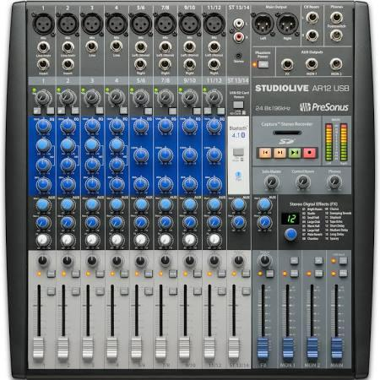

Figure 2. PreSonus StudioLive AR12 USB Mixer for $499

From Figures 1 and 2, it can be seen that these instruments offer a lot of customization and play with a DAW, but what you see is what you get. They are nice eye candy, and produce superb sound, but they lack the ingenuity of the Arduino and Teensy modules. What our group strived for in the undertaking of this project was to create a controller that is uniquely ours in appearance, usage, and a few other features that make it distinguishable. By using Teensy hardware with Arduino software to create our own MIDI controller, we have created a device that interacts with the DAW, as well as a device able to produce sounds of its own, independent of the DAW.

III. IMPLEMENTATION

*Software and Hardware Approach and Implementation*

Programming a MIDI controller with the built-in libraries provided by Arduino and Teensy were straightforward[3]. For the controller, a Teensy 3.2 microcontroller was used as the main chip, but programming was done with the Arduino platform. To program the Teensy without the use of an Arduino board (this applies to only Teensy 3.0 and up chips, as well as Teensy++ chips), a software add-on for Arduino called Teensyduino had to be installed[4]. This allowed usage of all the standard Arduino functions, as well as compatibility with most Arduino libraries.

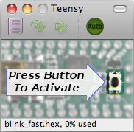

Figure 3. The Teensy Loader before uploading a sketch to the Teensy board.

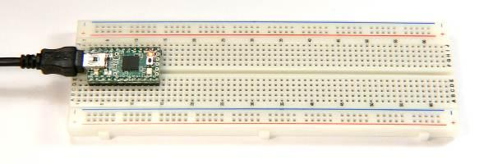

Figure 4. Plugging the Teensy by USB to change the type of board being used

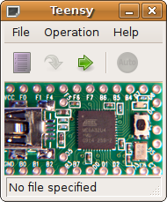

Figure 5. The window signifies that the Teensy board can now be used with Arduino.

Using the Arduino IDE, programming was done using the C language. It is a bit different from normal C, but that is essentially the main language used to write sketches (the names of programs in Arduino and Teensy).

With the Teensy 3.2 as the main microcontroller, we used other hardware parts to create the MIDI controller. With Arduino hardware, manufactured by the company Elegoo, we created a controller using wires, sensors, potentiometers, buttons, breadboards, and an old headphone case box as the outer shell to house all these components. As can be seen in Figures 6 through 8, the progress of making a MIDI controller is complicated. Getting it to work was easy; to actually make it interact with the DAW, a separate software entity, was not easy.

To get this part to work, the team programmed sketches to work with the computer. Using the MIDI (Musical Instrument Digital Interface) protocol[5], we got the controller to work with the software successfully. There are times when it messes up, and it has to be set up just right to work (hence why most musicians either do things with a mouse and keyboard, or they spend the money for high quality controllers), but when it is, it works very well.

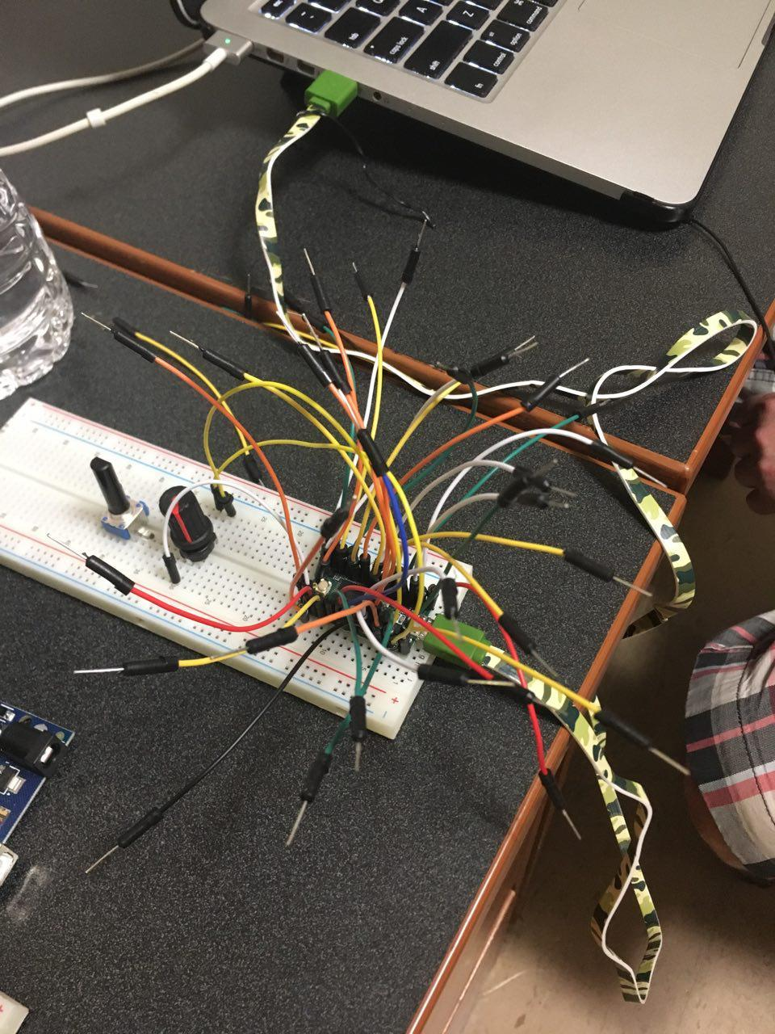

Figure 6. The Teensy 3.2 on a breadboard

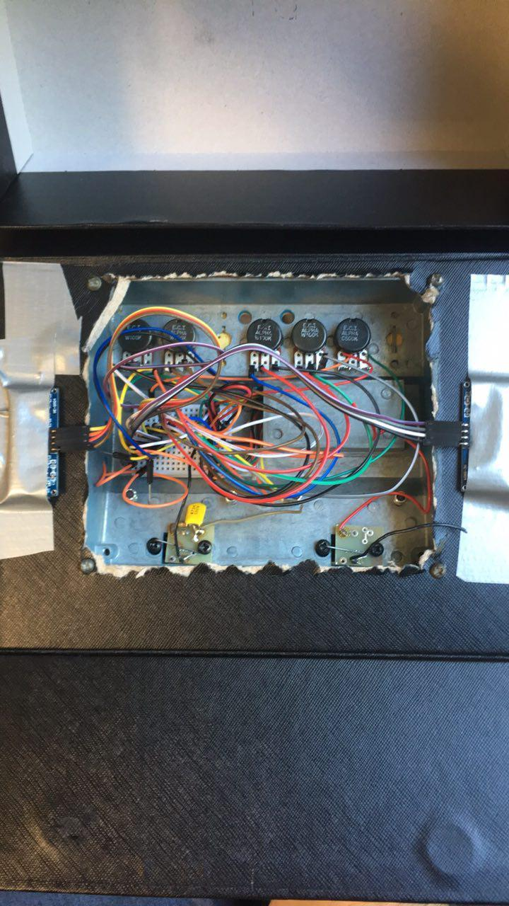

Figure 7. The inside of the controller; two ultrasonic sensors are attached on either side for control over certain aspects of music making, a makeshift theremin.

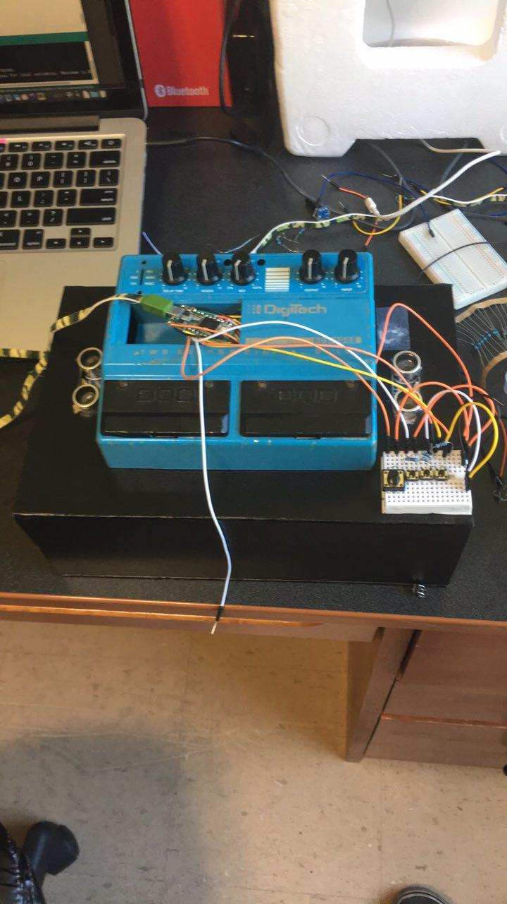

Figure 8. The outside of the controller.

V. CONCLUSION AND FUTURE WORK

To improve upon our pre-existing hardware solution, the Music Junkies development team could continue to expand the functionality of our MIDI controller. The problem our team addressed was building a cheaper alternative to a midi controller. MIDI controllers can get quite expensive, just putting in the time; we managed to save ourselves hundreds of dollars by building our own. This alternative solution is pretty impressive because the everyday citizen can’t say that they’ve constructed a midi controller from ground zero.

In order to improve our solution, the team will work on our reading points. This will be accomplished by improvements in implementation in the software, and better connectivity with improved hardware components. One main thing we look forward to accomplish in the future is the ability to synchronize a DAW position digitally and having that move physically on our hardware component. No signs of that technology exist just yet.

REFERENCES

[1] Edstrom, Brent, “Arduino for Musicians: A Complete Guide to Arduino and Teensy Microcontrollers,” Oxford University Press, 2016, pp. 1-2.

[2] Ibid, pp.243

[3] The Teensy Loader Application. Retrieved from

<https://www.pjrc.com/teensy/loader.html>

[4] The Teensy Loader Application. Retrieved from

https://www.pjrc.com/teensy/loader.html

[5] Libraries. Retrieved from https://www.arduino.cc./en/Reference/Libraries

BIOGRAPHY



Christopher John Vasquez Jr. began studying at Southeastern University in 2016. He transferred from Louisiana State University and is pursuing a degree in Computer Science. He was born and raised in New Orleans, Louisiana and was forced to relocate in 2005 to Texas due to hurricane Katrina. He now resides in Hammond, Louisiana.



Chris Wunstel has attended Southeastern since the spring of 2016 and will graduate with a Bachelor of Science in Computer Science, Scientific Concentration in 2017. When not studying Computer Science, Chris enjoys music creation and listening in his hometown of Baton Rouge, LA.



My name is Rory Avant. I am from Denham Springs., Louisiana. I have lived in Louisiana my whole life. I am a senior at Southeastern Louisiana University, and am majoring in Computer Science. I will graduate this Fall (Fall 2017). I value my family and progressing as an individual more than anything else. I am very close with my family. They mean everything to me, and I do not know where I would be without them. I have two siblings, who are both older than myself. I have a brother, who is six years older than me, and a sister who is two years older than me. They are two of my best friends, and are always there when I need them to be, as I am for them. I have several hobbies, which I spend much of my time doing. These include: programming, yoga, lifting weights, playing keyboard, and producing. I started programming when I was 19 years old, and began tinkering with playing keyboard and producing when I was 21. I enjoy getting immersed in both of these, and time seems to disappear when I get in that zone. I love traveling, although I haven’t been to many places, but after graduation, I plan to spend a lot of time doing that. I admire the diversity in culture, and cannot wait to get to experience how others cultures live. I first want to travel through the states before traveling to other countries. I believe I need to see what my home country has to offer first, before exploring others. My goals in life are: to make a career in the field of computer science, create my own business, produce tracks (music) at the level of a professional, consistently progress in both yoga, and weight lifting, to inspire others and help to bring out the best versions of themselves, and again, travel. I enjoy the company of others that I can have a deep conversation with, to talk about philosophy with, and hear their perception and thoughts on interesting matters. I believe there is unlimited potential within all of us, and that we must tap into that, and consistently work toward that potential to truly be happy. I try my best to stay positive and to not overreact to many of life’s trivial matters. I am very excited for the journey of life and to see where it takes me.



Tony Hoss started studying Computer Science at Southeastern Louisiana University in 2015 and plans to graduate by Fall 2018. He was born in Columbus, GA, and has moved to several places, including Texas, Guam, and Kansas. He also obtained his Bachelor Degree in Music Performance (Piano Concentration) from Southeastern in 2012, studying under Dr. David Evenson. He has come a long way in his studies, and loves to spend his time learning new music, reading, and trying anything new in life.